Quick Start Guide for SharePoint Online
Committee

February 2020 Edition

TABLE OF CONTENTS

Signing into SharePoint online 1-1
Overview of SharePoint Site 2-1
Quick Start Guide for SharePoint Documents 3-1
Quick Start Guide for SharePoint Announcements 4-1
Quick Start Guide for SharePoint Comments 5-1
Quick Start Guide for SharePoint Useful Links 6-1
Quick Start Guide for SharePoint Alerts 7-1
Quick Start Guide for Chairs 8-1
.

Signing into SharePoint online.

Committee Member Sign-in.

The Commission has moved to SharePoint online. To access the sites, you will need to have a Microsoft account that is tied to the email address that we are using to communicate with you.

To test if you have a Microsoft Account you can go to http://account.microsoft.com/account and try your credentials. From this site you can also create a free Microsoft account.

Once you have your Microsoft Account you are all set and will be able to experience Sharepoint Online.
In an email from the Commission, you will receive a link to a page that is similar to https://southernacscoc.sharepoint.com/sites/OS/trnghome. This link will be to your Cluster Home Page. When you go to the URL, you will be asked for your credentials, if you use Office 365 it might look like.

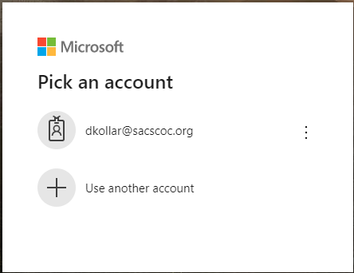

(Figure 1)

Else, you might get a screen like

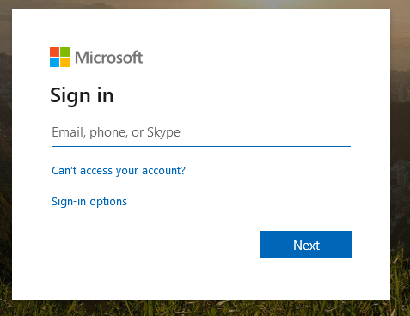

(Figure 2)

Either way you will need to put in your Microsoft account information as discussed above. Then you will be asked to enter your password.

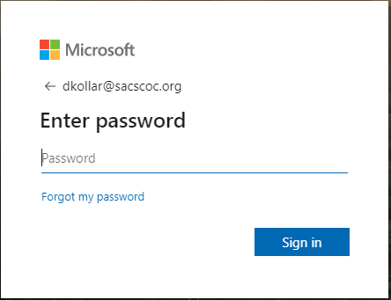

(Figure 3)
Overview of SharePoint Site

To have gotten this far you should have a Microsoft Account and received an email from SACSCOC. In that email is a link to a portal that begins with http://southernacscoc.sharepoint.com/sites/os/...... This link will end with a cluster number. This link will take you to Cluster home page. That page will be the main page that your cluster will use to navigate to the individual institutional pages.

On the SharePoint site we will be utilizing 5 areas:

- Subsites
- Documents
- Announcements
- Useful Links
- Comments

We will discuss each of these sections later in the guide.
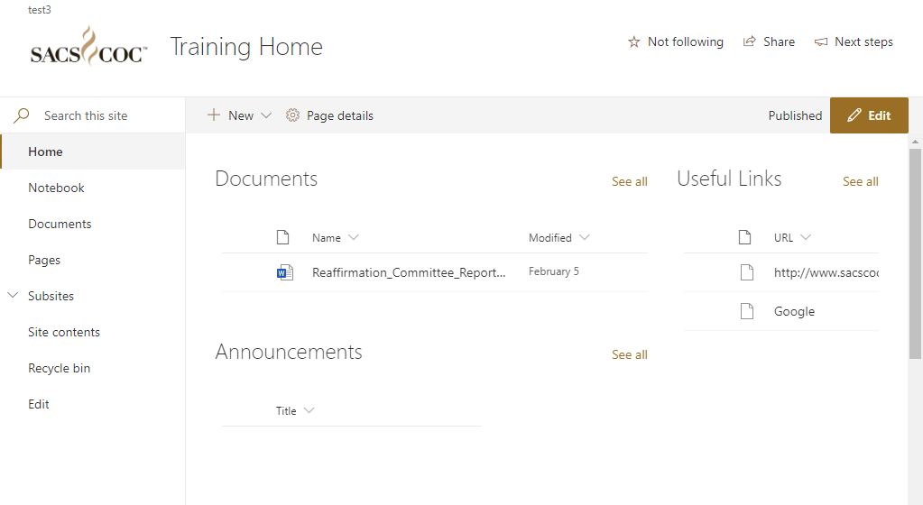
1
1
1
1
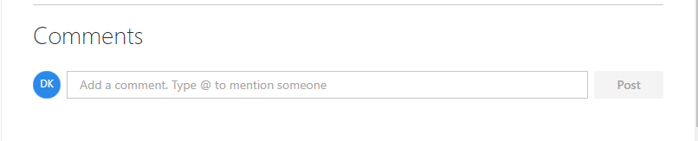
1
(Figure 1)

Navigating Between Cluster Home and Institutional Pages

Each cluster will have the cluster home page and subsites for each of the institutions they are reviewing.

The individual pages will be listed under subsites on the left-hand side of the screen. You will need to click on the down arrow beside Subsite (See Figure 2) to see the links.

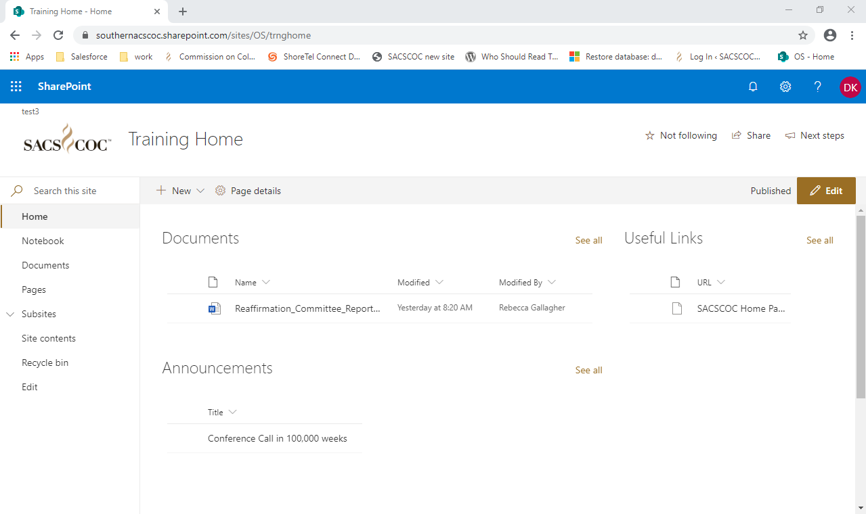

(Figure 2)

Once you click on the down arrow you should see any subsites to this page. (See Figure 3)

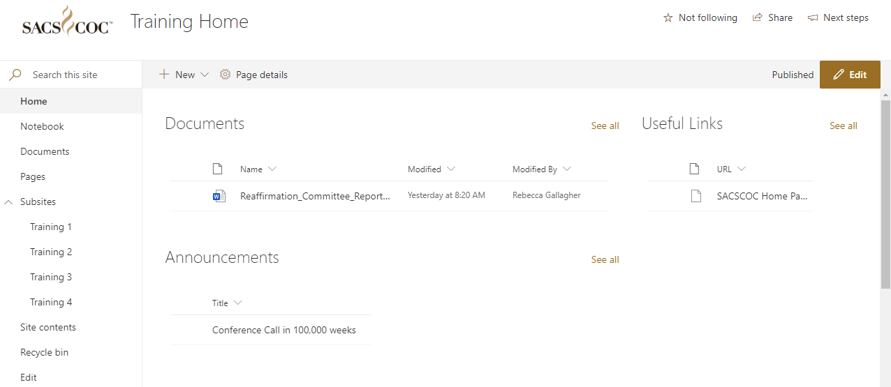

(Figure 3)

On the subsites under Links there will be a Cluster Home link (See Figure 4) that will return you to this main page.
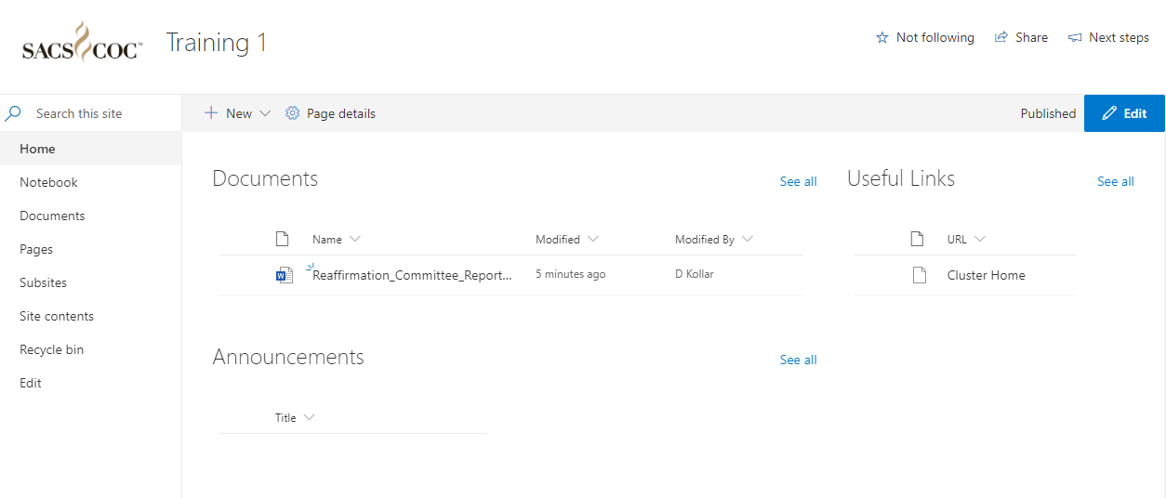

(Figure 3)

Quick Start Guide for SharePoint Documents

Note: Documents no longer requires checking in/checking out to work on the document. Multiple people can use the document at the same time. However, to get this ability, we do lose the version history.

Once you have completed your review of the institution and written your analysis of the institution’s compliance with the Principles of Accreditation, you are ready to add that analysis into the shared report for the institution using the SharePoint program. Follow the steps listed below to transfer your analysis to the shared document.

- Navigate to the institutional portal page
- Click on the Document you wish to Edit (Figure 1)
(Figure 1)

- When the document opens you should notice that it is in editing mode. (See Figure 2). When you make an update to the document, the word “saved” will quickly change to Saving.momentarily.. (sorry cannot capture this here)

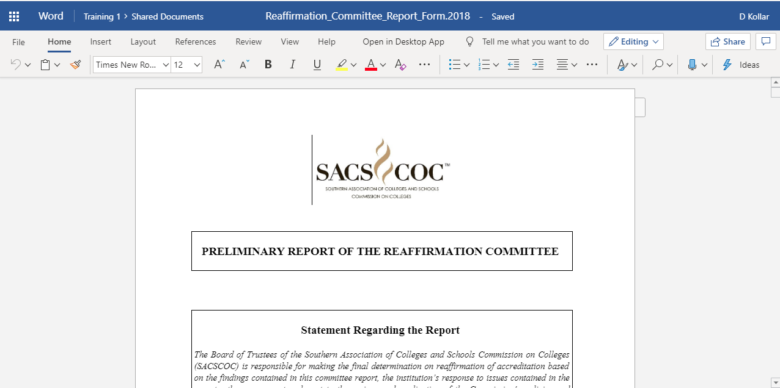
(Figure 2)

- Open your Off-Site Review Analysis Worksheet. (Word)
- Copy from your Off-Site Review Analysis Worksheet. (Word)
- Paste into the appropriate sections of the Reaffirmation Committee Report.
(Note: To expedite your work, we recommend that you compose your comments using the Off-Site Review Analysis Worksheet and copying and pasting them into the Sharepoint document.)
- Please be careful as you are working live on the document.
- When you are through updating your report, please close the browser/browser tab.

Reviewing a document

After the deadline for completion of your Sections, the document will be locked by the Committee Chair. You will be able to review the document but will not be able to make changes. To distinguish the document that has been locked you will see a circle with an arrow in it (See Figure 3). If you see a required change, please contact your Committee Chair, or bring the edit with you to the meeting in Atlanta.

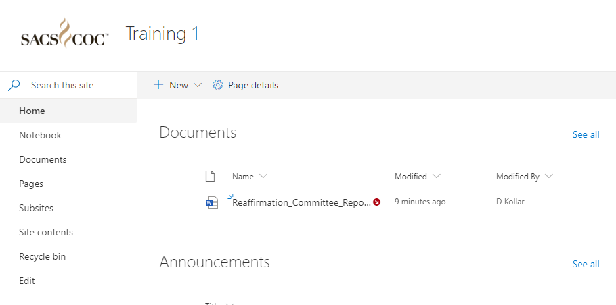
(Figure 3)

- Click on the document you need to review. This will bring the document in review mode.

Quick Start Guide for SharePoint Announcements

Use an announcements list to post news, status, and other short bits of information you want to share with team members

Add an Announcement
- From the home page you will see Announcements
- To the right of Announcements you will click on See all.. (See Figure 1)

(Figure 1)

- When you get to the Announcements page click on the + New (See Figure 2)
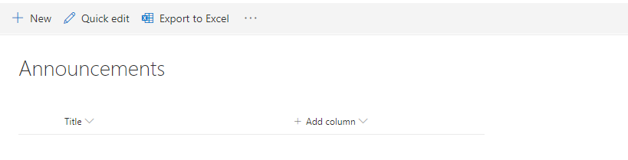
(Figure 2)

- Now enter the information for the Announcement (Figure 3)
  - Title – Click on where you see Enter value here and input the title for the Announcement.,
  - Body – Click on the pencil to the right of the field.
  - Expires – Not Required. This is a date, where Sharepoint would remove the Announcement from the home page for spacing purposes.
  - Attachments – Click on Add attachments
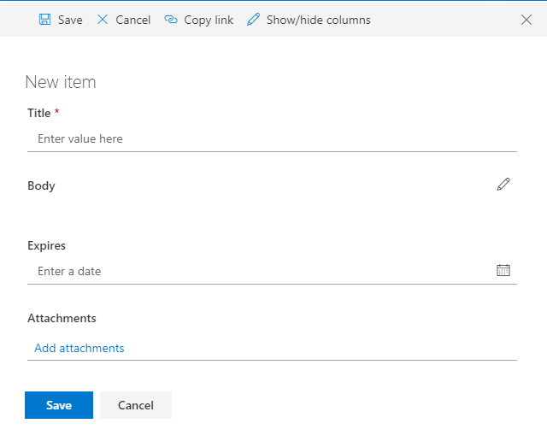
(Figure 3)

- When you click on Add attachments, you will be taken to a view of your folders on your computer and you will navigate to the location of the file you wish to upload and then click Open.
- After you have updated your information you will click on the Save button.

Edit an Announcement
- From the home page you will see Announcements
- To the right of Announcements you click on See all (See Figure 1)
- Select the Announcement you wish to edit, by clicking on the left of the title (See Figure 4)
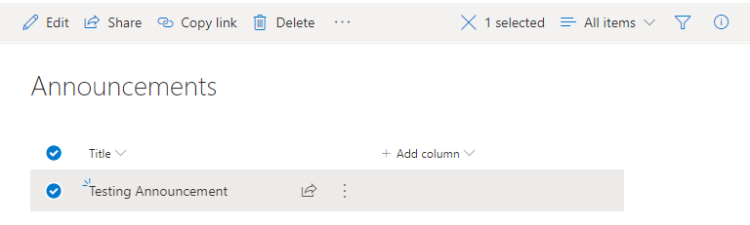
- Then click Edit
- Make any updates needed to the Announcement (See Figure 3)
- Click Save.

Quick Start Guide for SharePoint Comments

Comments are a place to make “comments” about the institution being reviewed.

Add a new Comment
- Beneath Announcements you will see Comment.
- To add a comment, type the comment into the box provided and click on Post.(See Figure 1)
- To reply to the Comment, click on the Reply that is directly below the Post you wish to reply to.

Figure (1)

Quick Start Guide for SharePoint Useful Links

Useful Links are like Favorites, as a quick way to include an address to external sites from a particular site.

Add a new Link
- Click the See all to the right of Useful Links (See Figure 1)
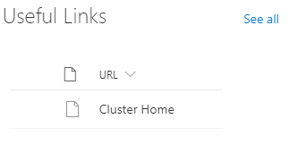
(Figure 1)

- Click on the + New (See Figure 2)
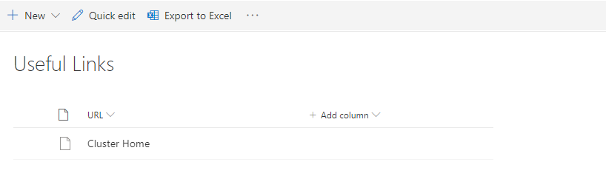
(Figure 2)
- Select item (See Figure 3
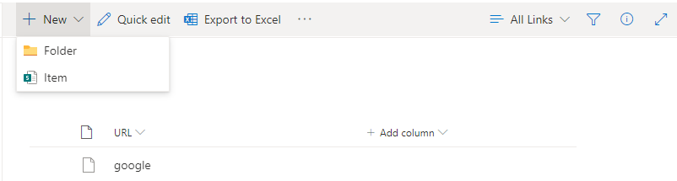
(Figure 3)

- Enter your URL (web address, must include http://) and display text (description). (See Figure 4)
Hit Save once you’re done. (See Figure 4)

(Figure 4)
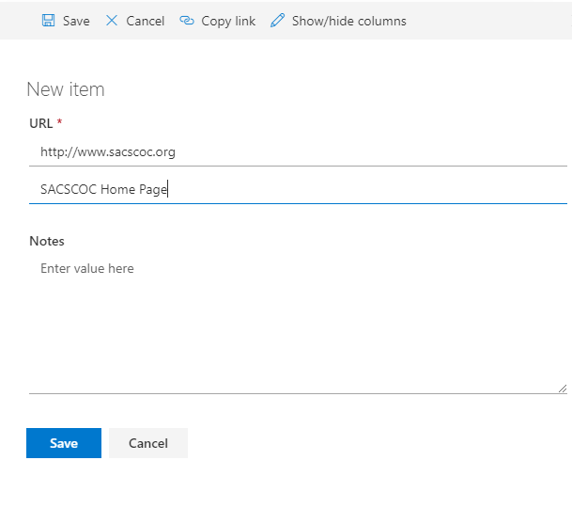
(Figure 4)

- You should now see that the SACSCOC Home Page is displayed on the home screen. (See Figure 5)
(Figure 5)

- If you do not put in a description, then the url will be displayed. (See Figure 6)
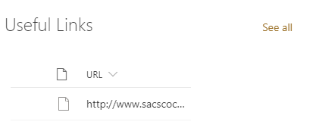
(Figure 6)

Editing a Link

- To the right of Useful links, you click on See all (See Figure 6)
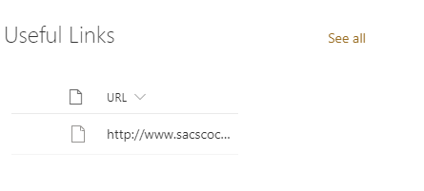
(Figure 7)
- Select the Useful link you wish to edit, by clicking on the left of the title
- Then click Edit (See Figure 8)
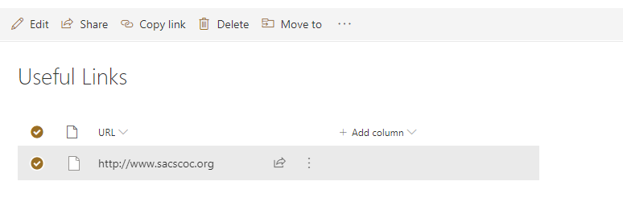
(Figure 8)
- Make any updates needed to the Useful link
- Click Save. Your correction will be displayed. (See Figure 9)
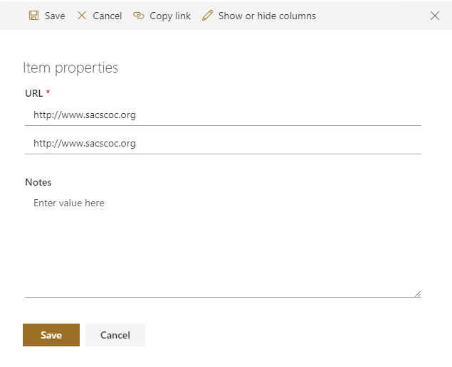
(Figure 9)

Quick Start Guide for SharePoint Alerts

Alerts allow the system to notify you when changes are made to pages or sections of the pages. I suggest that you set up alerts for the following areas for you clusters’ main page and institutional pages.
Documents
Announcements

Add a new Alert
- From the home page. Click on See all next to Documents and/or Announcements. (See Figure 1)

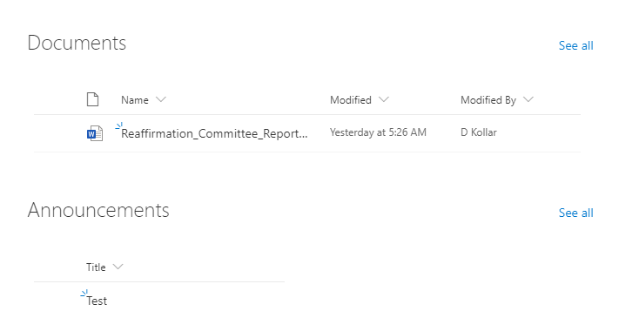
(Figure 1)
- From the toolbar click on the 3 dots and you will see Alert me and Manage my alerts.
- Click on Manage my alerts. (See Figure 2)

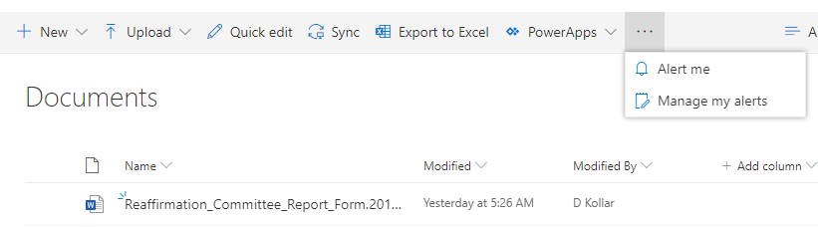
(Figure 2)

- Click on Add Alert (See Figure 3)

(Figure 3)
- You will click on Radio Button to the left of Documents and/or Announcements, and then click Next. (See Figure 4)
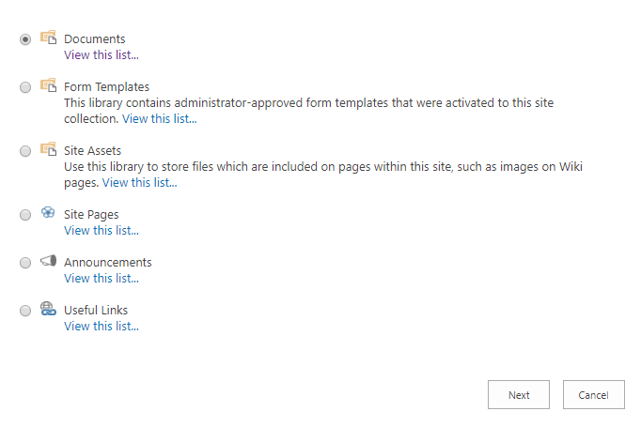
(Figure 4)

- On the next page you will need to Select (See Figure 5)
  - Delivery Method – Should be email address. SMS not supported by Commission.
  - Change Type – (We recommend All Changes)
  - Send Alerts for These Changes - (We recommend selecting Anything changes)
  - When to Send Alerts – We recommend a daily summary, and you can select a time for the alert to be sent. (Eastern)
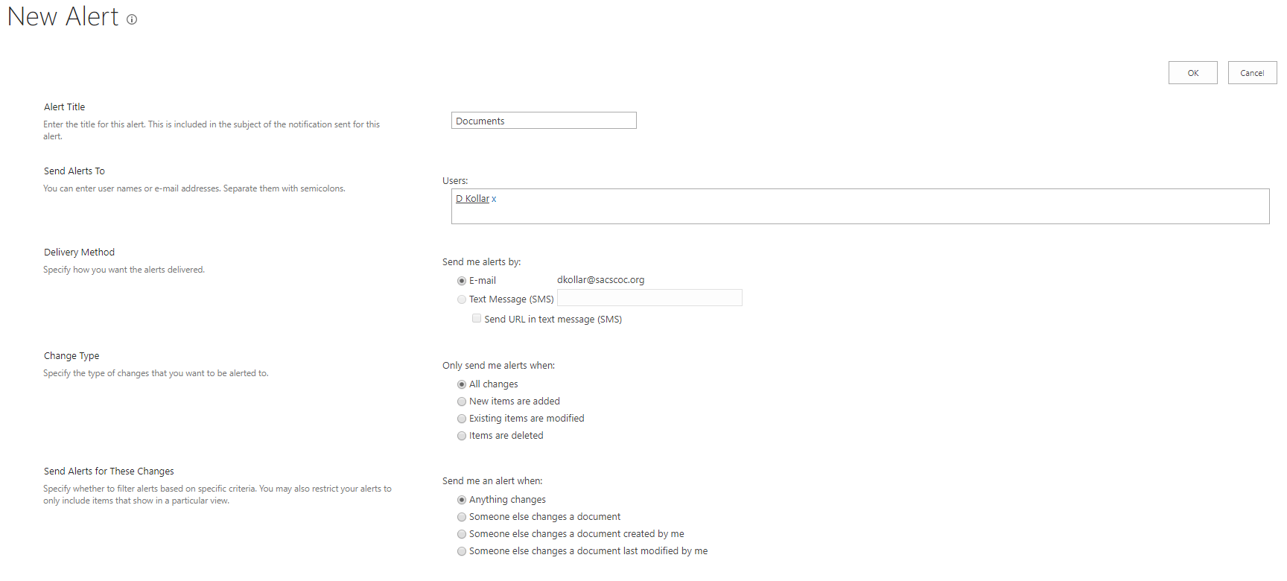
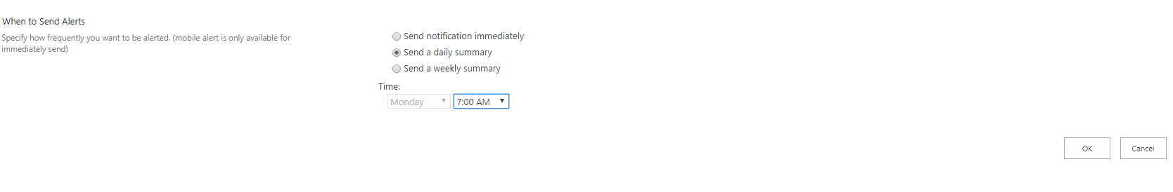
(Figure 5)
- Click on OK
- Repeat as necessary for other Alerts.

Quick Start Guide for Chairs

Chairs have permissions and responsibilities that the other committee members do not have.

These permissions and responsibilities are explained in this chapter.

Create a Chair Version of the Committee Report

After the committee has finished inputting their sections of the document and the established due date has arrived, the chair will need to do the following with the report.

- If you scroll to the right of the document name you will see 3 dots. (See Figure 1)
- Click on the 3 dots.
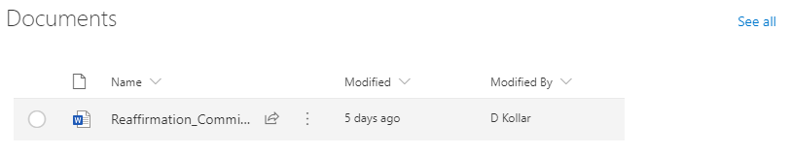
(Figure 1)

- Click on More at the bottom of the menu
- Click on Check out. (See Figure 2)
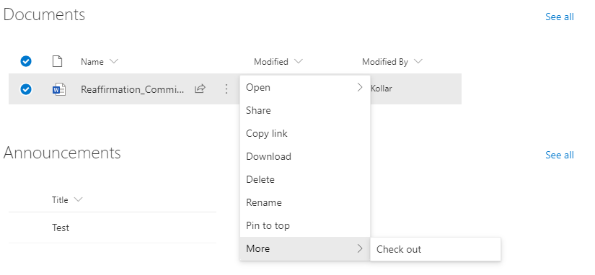
(Figure 2)

- A circle with an arrow will appear. (Document is checked out) (See Figure 3)
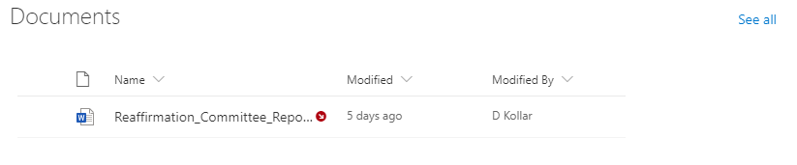
(Figure 3)

- Click on the document open, then do a Save As to your computer.
- Change the name to include Chair Version.
- Make any changes needed to the Document.
- Save the Document

Uploading a chair version to portal site.

- Click on See all next to documents. (See Figure 1)
- Click on Upload. (See Figure 4)
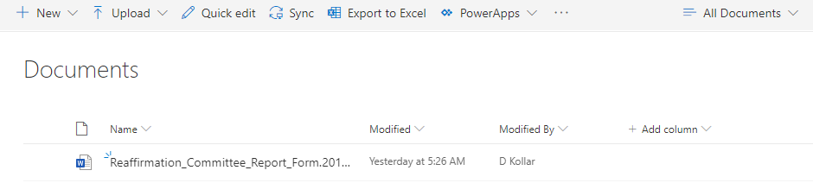
(Figure 4)

- Click on Files (See Figure 5)
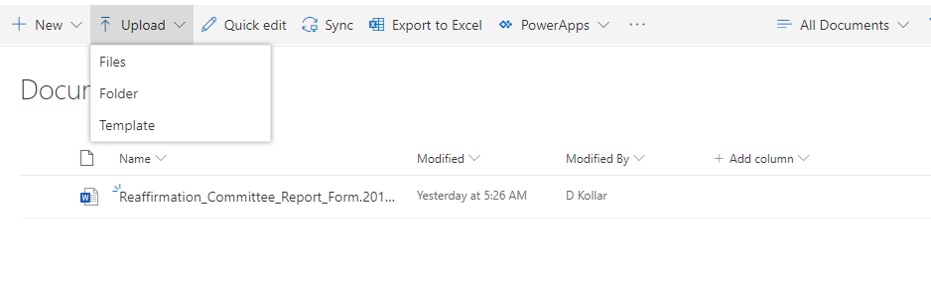
(Figure 5)

- This will take you to a representation of your computer.
- Navigate to the location of the Chair Version of the Document.
- Highlight the document.
- Click Open
- Document will be added to List.
- Check out document as explained above.

Note: Your committee members will be able to see the document, review the document, but not edit the document.

Note: When ready, notify the Cluster Recorder that the document is ready. They will then download and edit the document for formatting, and then they will upload the Final Draft to the Cluster Home Page for review. I usually suggest waiting on this until all institutions are reviewed, in case you need to make changes for consistency.

Other suggestions for Chairs

- Put all dates (deadlines, conference calls) in Announcements of each portal page. Cluster Home and Institutional
- Create an alias for each institution. That way if you need to talk about something via email, you can use the alias and not the institution name.

Workflow for SharePoint

